CODE:

from random import \*

from random import \*

while True:

temperature = randrange(0,100)

humidity = randrange(0,100)

if (temperature>=50):

print("Alarm")

else:

print("No Alarm")

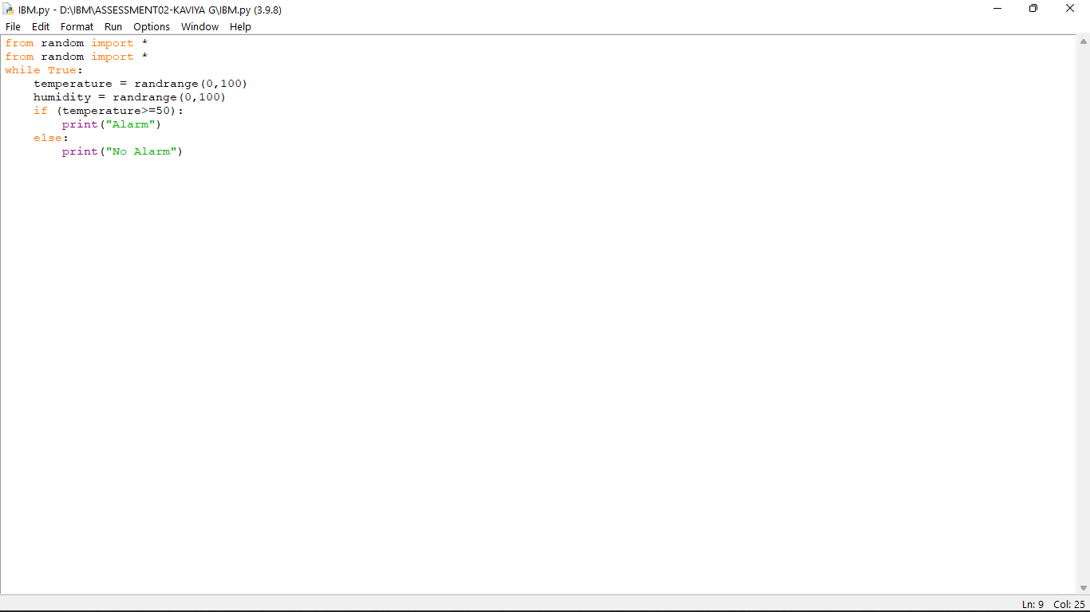

OUTPUT: